**PF LAB 4**

**FLOWCHARTS AND C CODES**

**Q.1)**

OUTPUT Number is a multiple of 3

Remainder = 0?

Number/3

INPUT number

NO

YES

OUTPUT Number is not a multiple of 3

**Q.2)**

OUTPUT Multi

OUTPUT Div

OUTPUT Diff

OUTPUT Sum

OUTOUT Invalid operator

Division= num1/num2

Multiplication= num1*num2

Op ‘/’?

Difference= num1 –num2

Op ‘*’?

Op ‘-‘?

Sum = num1 +num2

Op ‘+’?

INPUT num1, num2, op

NO

NO

NO

NO

YES

YES

YESS

YES

**Q.3)**

NO

YES

OUTPUT Special character

OUTPUT Digit

NO

NO

YES

YES

Small alphabet?

OUTPUT Small alphabet

OUTPUT capital alphabet

Digit?

Alphabet?

INPUT single_ch

**Q.4)**

YES

NO

OUTPUT Amount not eligible for discount

cost<500

OUTPUT Saved amount, amount after discount

Saved amount=cost*35/100

Amount after discount=cost-(cost*35/100)

YES

NO

cost>6000

4000<=cost<=6000

OUTPUT Saved amount, amount after discount

Saved amount=cost*20/100

Amount after discount=cost-(cost*20/100)

YES

OUTPUT Saved amount, amount after discount

Saved amount=cost*10/100

Amount after discount=cost-(cost*10/100)

2000<=cost<4000

NO

YES

OUTPUT Saved amount, amount after discount

Saved amount=cost*5/100

Amount after discount=cost-(cost*5/100)

500<=cost<2000

SET saved amount, amount after discount

INPUT cost

**Q.5)**

OUTPUT Total amount to pay

YES

OUTPUT Surcharge amount, Total bill

Surcharge amount=b4*15/100

Total bill=b4+(b4*15/100)

NO

b4>18000

OUTPUT Total amount to pay

NO

NO

YES

YES

OUTPUT Invalid number of units consumed

b4=units*35.90

units>=500

b3=units*27.10

OUTPUT Total amount to pay

NO

YES

300<=units<500

b2=units*20.10

NO

YES

200<=units<300

OUTPUT Total amount to pay

b1=units*16.20

units<=199

SET Total amount to pay=b1, b2, b3, b4

INTPUT id, name, units

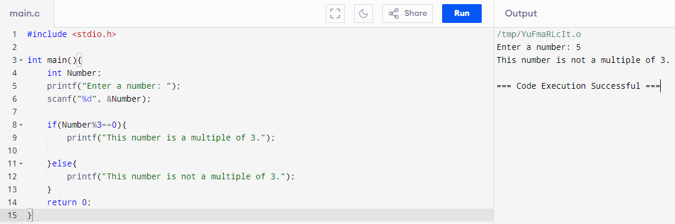

QUESTION 1

QUESTION 2

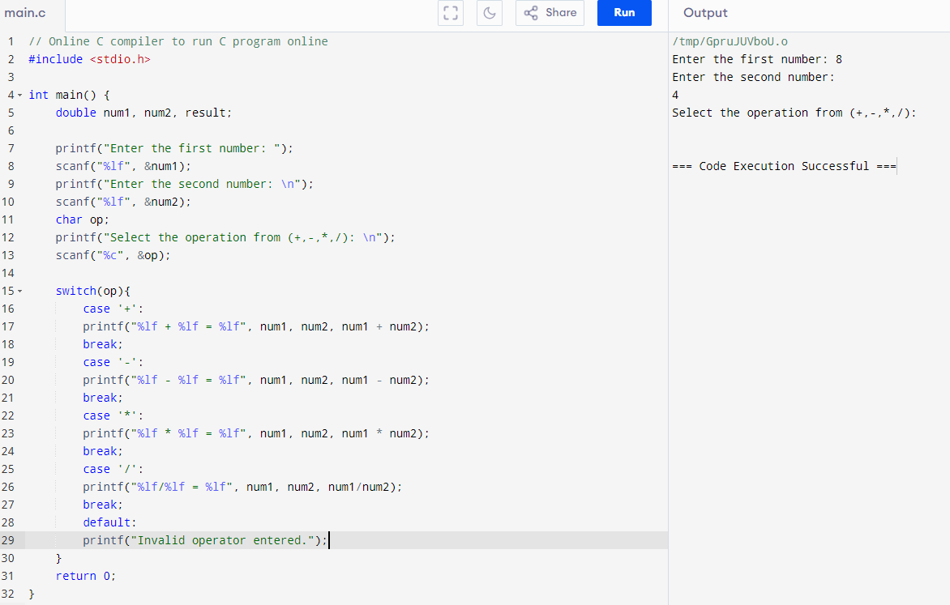

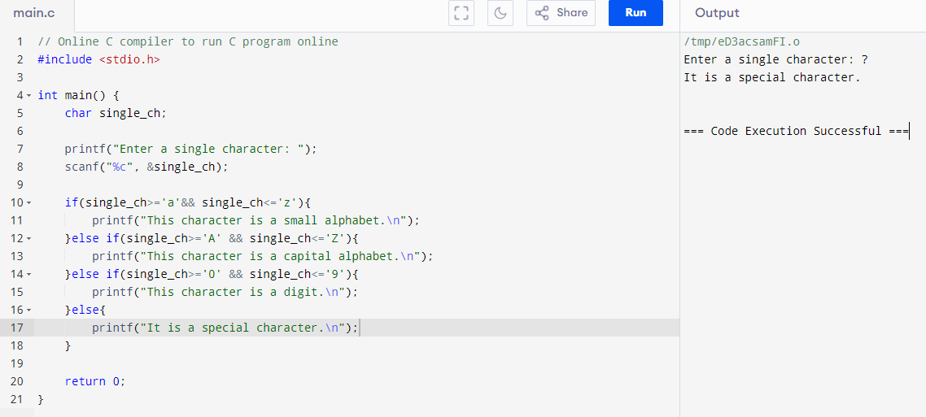

QUESTION 3

QUESTION 4

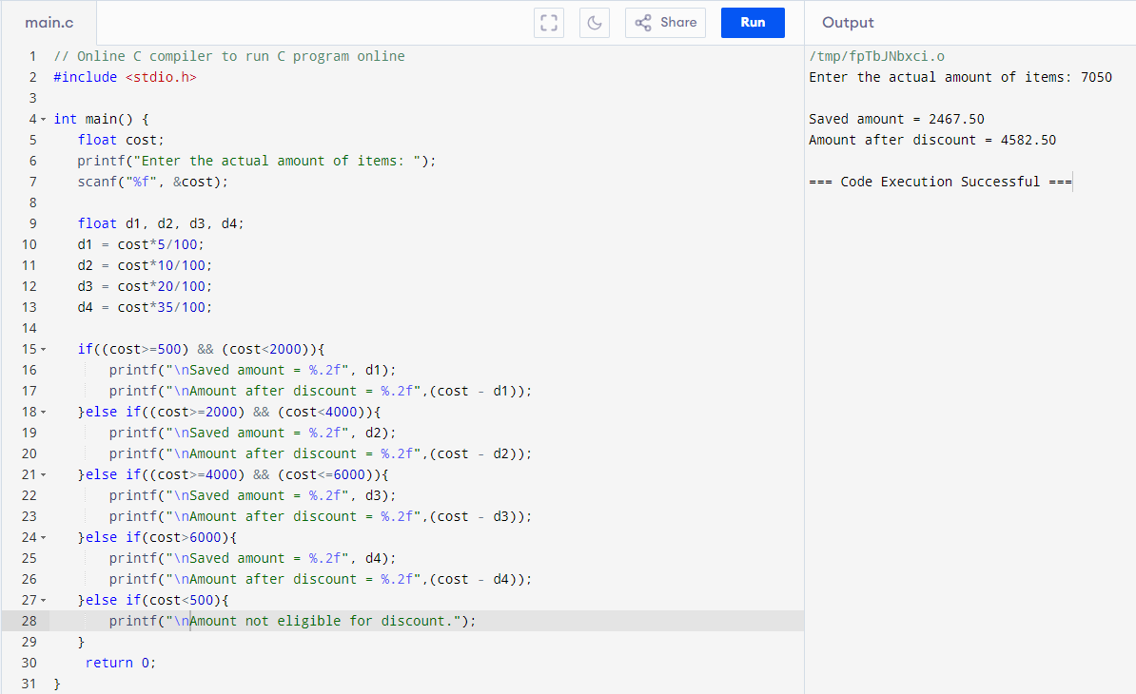

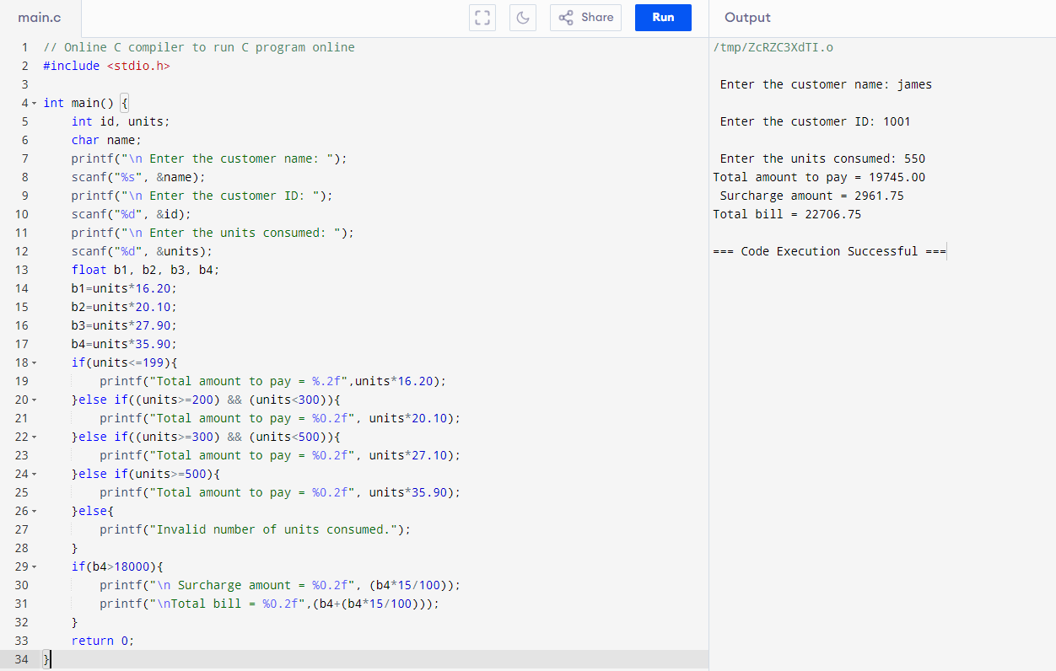

QUESTION 5

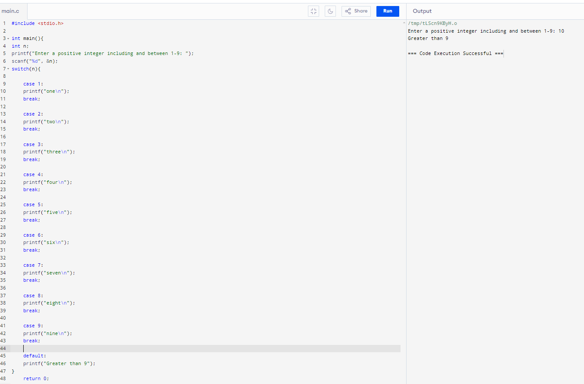

QUESTION 6

QUESTION 7

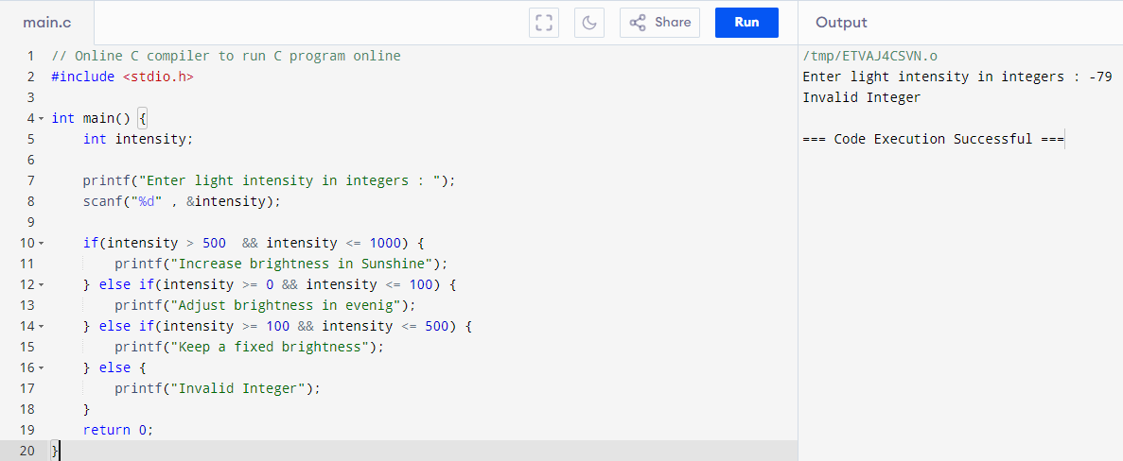

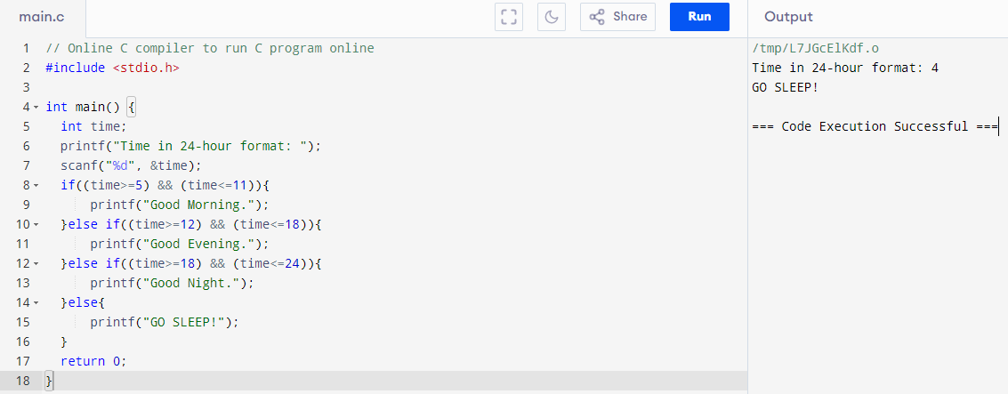

QUESTION 8

QUESTION 9

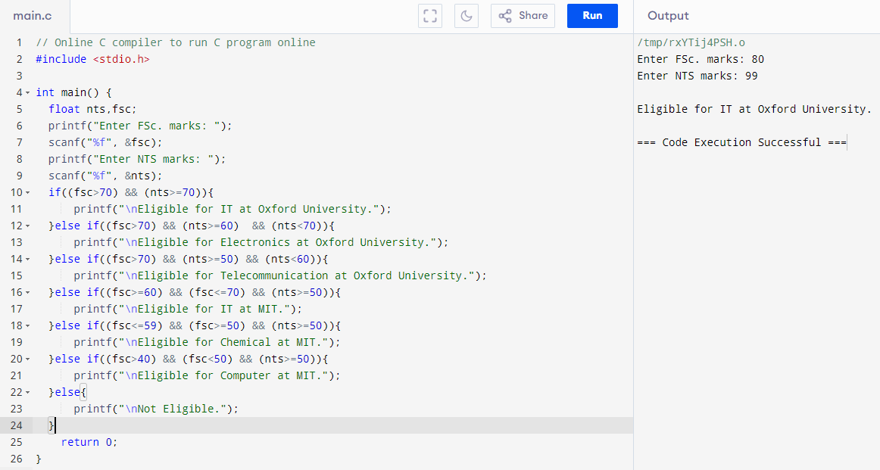

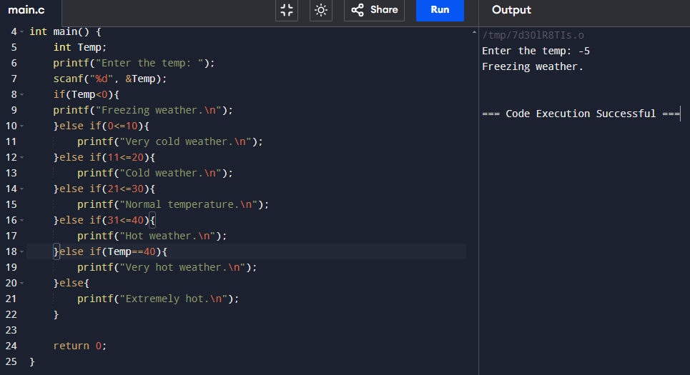

QUESTION 10